Work Plan for Prerequisite Issues for Debond Design

Draft Version 2 – 2/23/08

Background
The goal is to update PGSuper to satisfy TxDOT and WSDOT requirements for debond analysis and eventually a design algorithm for debonded girders. This document describes changes required for this implementation.

User Interface Changes
The current version of PGSuper supports analysis for LRFD debonding; however TxDOT has additional debond length requirements to be supported by changing the UI follows:

Project Criteria Debond Tab
The current debond tab does not include criteria for maximum debond length, or minimum release strength for debond design. The tab will be modified to look as below:

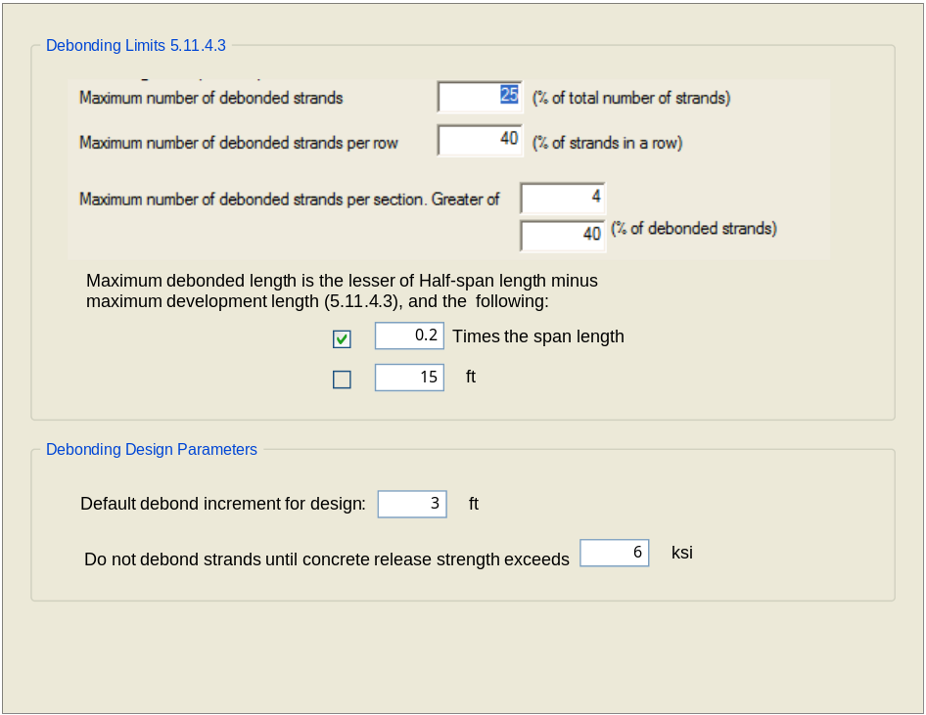

Girder – Permanent Strands Tab
The debonding limits for some TxDOT girders vary from a uniform standard. Hence the limits are girder specific and must be dealt with in the Girder Library. The figure below shows the option to override the global project criteria limits for a specific girder.
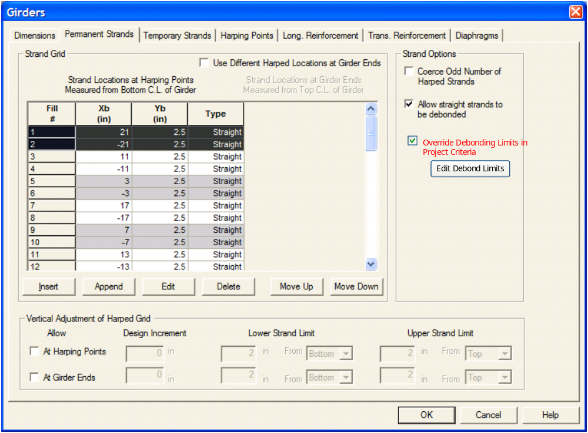
If the override option is checked, the limits can be edited for that particular girder. The following dialog is shown when the Edit Debond Limits is pressed:

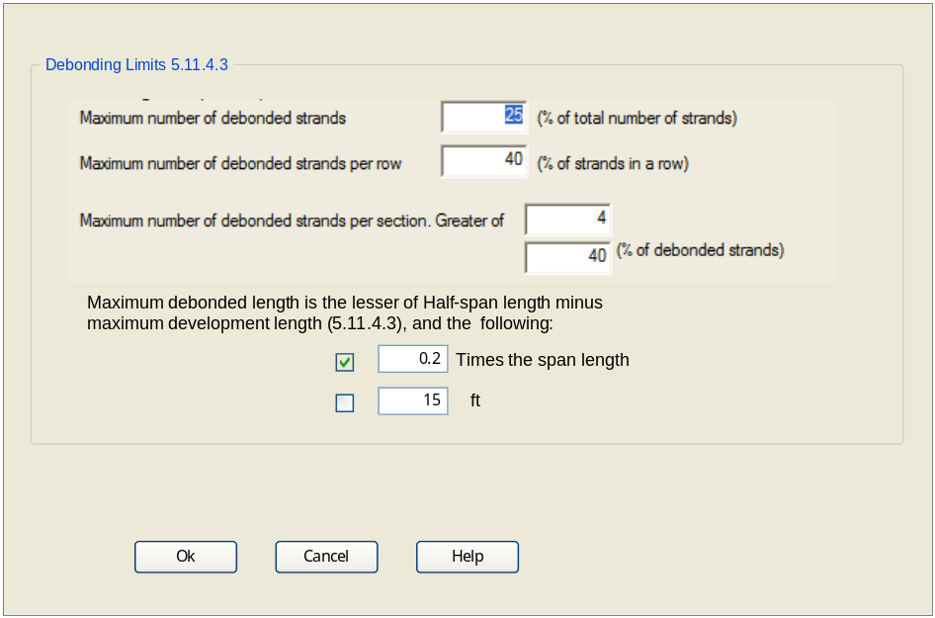

Status Center
Create a level 2 (yellow) status entry if any strands are debonded beyond the user-specified limits. The analysis will continue, but resulting in a Failed Spec Check. Direct user to the Girder Editor – Debonding tab to remedy.
Create a level 2 (yellow) status entry if any strands are debonded and the release strength is less than the minimum for design (e.g., 6ksi).

Spec Checking / Analysis
A Fail will occur in the Specification Check if any debond length exceeds the defined maximum. This must be reported in the Specification Check Report and the Details Report.

Add a Fail if debonded strands in alternate rows are not staggered.

Reporting
- Report max debond length in Project Criteria chapter
- Add max debond length check to Spec Check Report. The Spec Check will fail if over-debonded strands exist.
- Strand Eccentricity table does not collapse Point of Interest (POI) locations. This should be done to conserve report space.
- Currently POI’s for all analysis results are created at debond locations and at transfer-length (TL) from the debond locations. This creates congestion in the reports and lengthens analysis times. Scott recommends that we only report output at the TL locations – is this adequate?

Bugs
- Here is a prestress stress graph for 61.49’ debond of a 123’ girder. This only happens if a debond location is less than the transfer length to mid-girder. This is obviously a bug and should be investigated whether or not we allow debond lengths into this region:
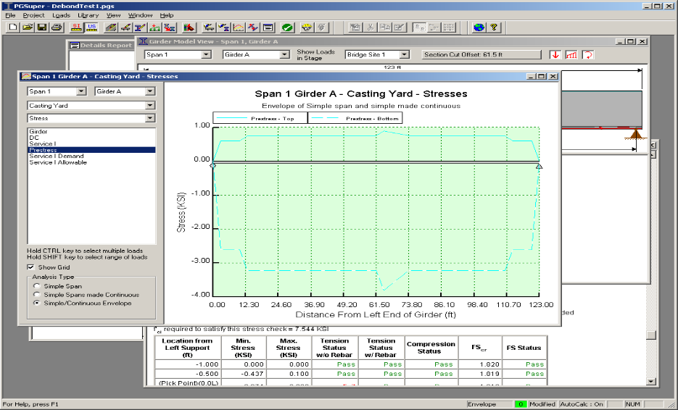
- Change in strand type does not update xfer locations in reports? This bug appears to have been fixed.

Issues
Scott made the following comment in BT:

“PGSuper has the capability, and is in fact already setup to consider the lack of bond of prestress strands over the transfer length during the analysis. The question then becomes, do we want to utilize this from a design standpoint? Using the stress at 2.5' to set debonding at 3', 5.5' for 6', etc. Granted it is the most accurate way to determine the amount of debonding required, and in some cases we may be able to specify less debonding than we would using the conservative simplification. However, I seem to recall that the fabrication tolerance for debonded length is plus or minus one foot. If the debonding was 1 ft short, using the more accurate method, we would now be unconservative, where as there wouldn't be a problem if we used the simplified PSTRS14 method. It is probably only a small difference either way. Thoughts?”

Scott is correct, PGSuper currently accounts for transfer length when computing prestress stress.

If simplifications are made in design that are not made in analysis, it is likely PGSuper will come up with a design that might not check. This has been unacceptable in the past.

Should the 6” “design offset” proposed be an optional distance?

TxDOT beam plans state “Debonded lengths shall decrease working inward, with debonding staggered in each rows”. Seems like common sense, but neither of these criteria appear in the AASHTO or TxDOT specs: Should these be optional? Should spec checks fail if either rule is broken?

All criteria that are not defined in AASHTO should be optional. If they are not criteria that use parameter values (like N% of strands in a row), then all TxDOT specific, non-AASHTO criteria, could be encapsulated in a single “Debond in accordance with TxDOT Bridge Design Manual Section XYZ”) option.

Currently PGSuper limits the debond length at ½ of the girder length. This means that strands can be effectively be debonded full length. For short girders, TxDOT limits the debond length to one-half the span length minus the “maximum development length” – AASHTO 5.11.4.3 states: “The length of debonding of any strand shall be such that all limit states are satisfied with consideration of the
total developed resistance at any section being investigated” Is this the same statement, should the TxDOT criterion be an option?

Is “maximum development length” intended to mean: development length computed using fps=fpu (e.g., 270ksi), or fps=”average stress in prestressing steel at the time for which the nominal resistance of member…”?

We’ve discussed full length debonding in the past, do we want this? If so, we need to add an option to specify it explicitly.

Addition to allow or deny debonding of individual strands would give more control over debonding to library creators and probably make spec checking less buggy – should we do this?

For U Beams, the TxDOT Spec states: “Half-span length minus the maximum development length specified in the AASHTO LRFD Bridge Design Specifications, Article 5.11.3.” This should be “5.11.4.2”. (this criterion actually appears multiple times in the spec – others are correct).

